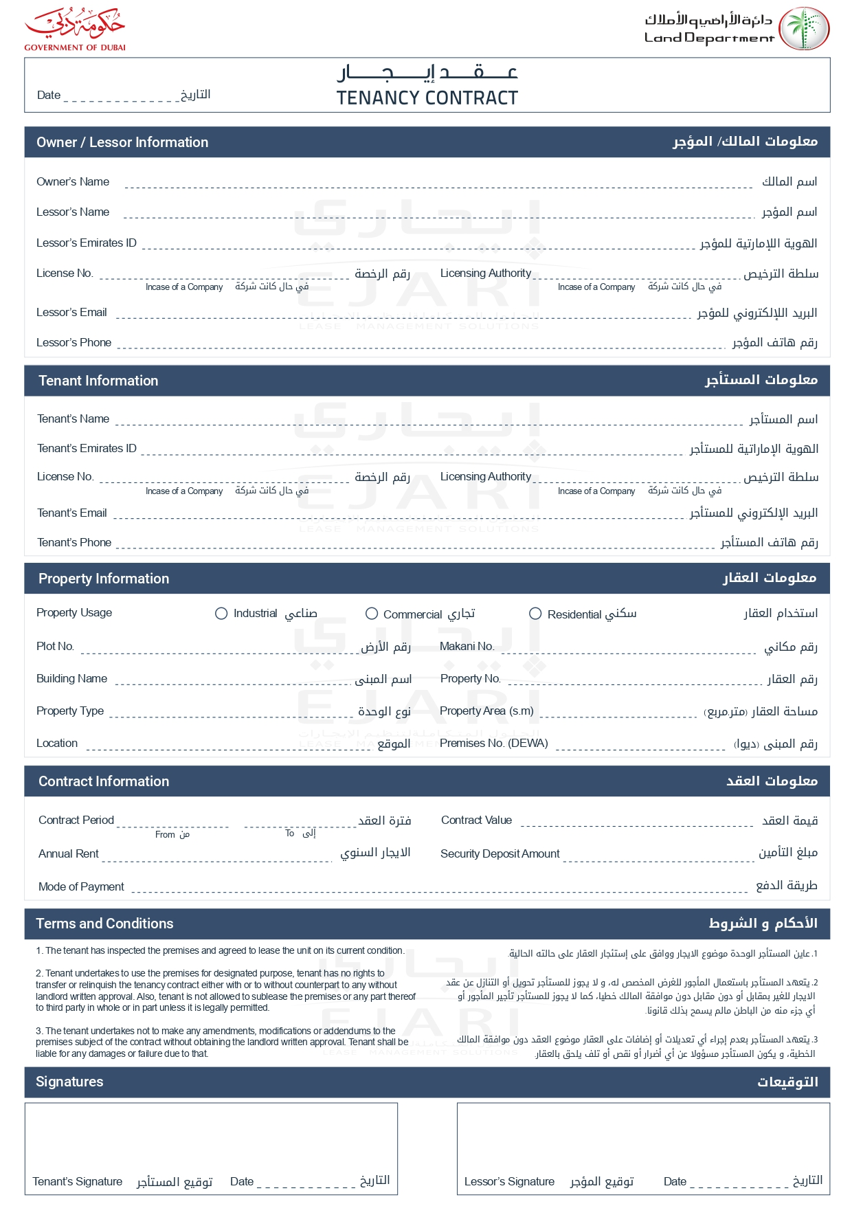

2025-04-08

John Smith

John Smith

john.smith@example.com

+971501234567

Emily Brown

emily.b@example.com

+971505678901

✓

G-102

Green Villa

1,300.00

GV001

1,100.00 AED

2025-08-08

2025-04-08

0.00 AED

1,100.00 AED

Weekly

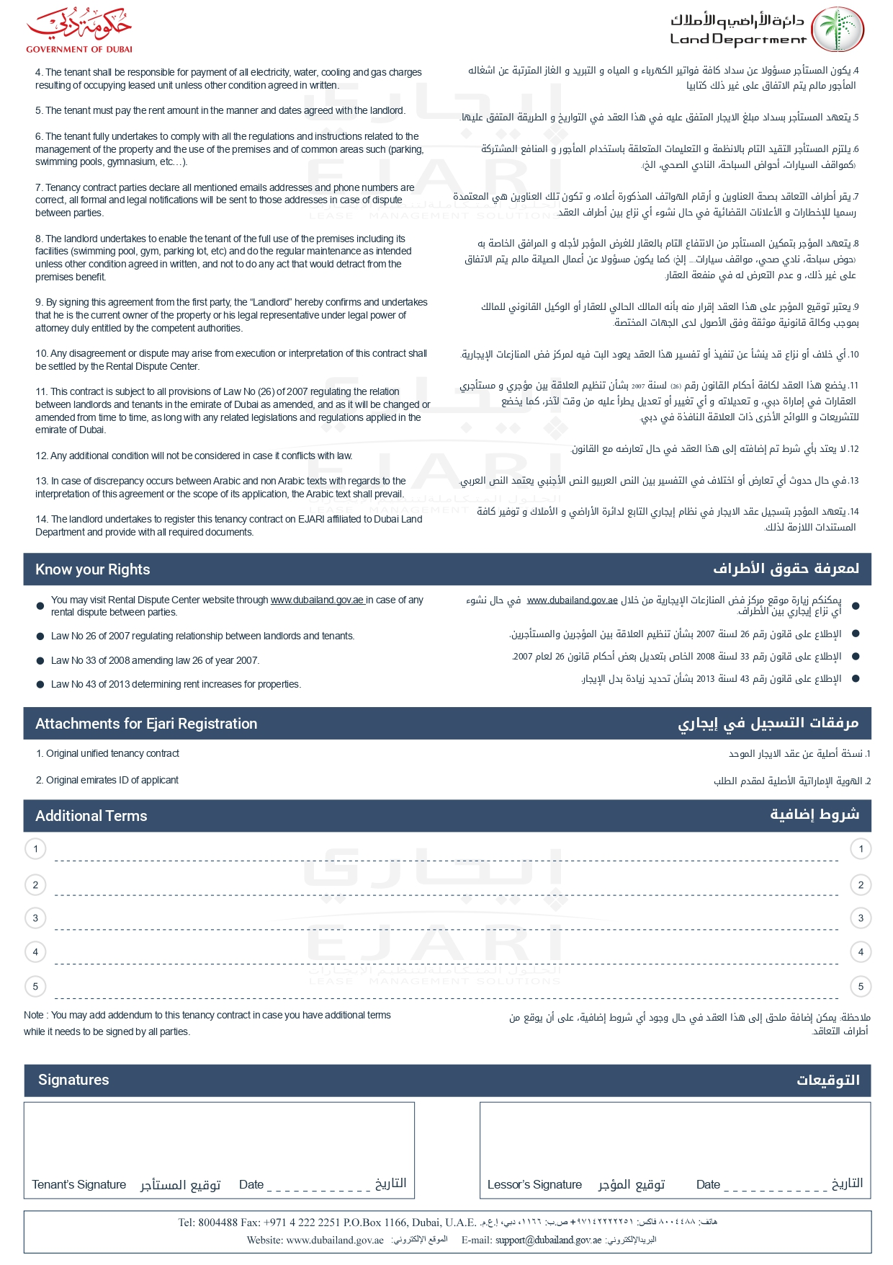

string1

String 2